- We need make it more friendly

- This is service website

- I need add customer rewards point to attract customer come back our web

- Previous web, admin never direct collect money

1. If user create a job, so system will charge 2.00 per sms for vendor who click button “sent proposal”

I

Now our IDEA is want 2 package that can let vendor selectd:

1. Commission BASE - Like Freelancer.com
2. SMS base - Like existing website [vshopi5.com]
3. Vendor can change package any time
4. SMS base is basic - vendor cannot create voucher - Function is disable but he can activate to Commission BASE anytime to change back. When change back to basic so all function will close it like voucher, ads…

* I want add bidding function and ads

- Competitor is recommended.my // Bidding & notification function

* User can create milestone LIKE freelancer.com

1. User pay amount into admin account as hold fund
2. When user “release” fund so amount will go to vendor after deduct commission
3. This must have report to user, vendor, super admin.
4. If vendor complete job - but user no release amount so vendor can sent photo as proof to admin. So admin will take action like “auto release” amount
5. When create milestone or release milestone must sent info into chat box to let vendor know. LIKE freelancer.com
6. If user cancel the job so the money of milestone will store in his account because our system will not refund cash.

- can let vendor choice package- charge SMS[done already] or commission base?

- pop up voucher

- vendor can be user OR user can be vendor

- Top Bar – customer CAN view they available voucher

Show quantity vouchers and icon voucher.

Username display

FAQ

Seller Centre

I want user coin show on top so user will know how many coins he have. But must auto update when use it.

- User can find do ""**Reviews from top to low or low to top**"" for "reviews of vendor" - so they can choice what company that he want? LIKE freelancer.com

* Update, Edit Customer can change his profile - Have already
* Add function for Update, Edit, Remove Bank & Card
* Modify “view all jobs” - user can view back what job that he post and successful but cannot be edit is vendor confirm order.
* System Update – If user give rate/reviews, he can get user point

 WILL display all voucher that vendor create and admin create. So user can use this voucher.

* User can sorting for voucher

1. May be many vendor will create voucher and sent to all user so user NO TIME to view all.
2. They can select category and subcategory to view voucher. Because vendor create voucher need select category and subcategory



This coins need display in Top bar. But this icon can let user click inside see detail. Where he use it.

* Customer can chat with admin and seller.

1. If SMS charges - if vendor click “sent proposal” button, so system will charge vendor who sent the proposal.so can chat with vendor [Done already]
2. If commission base - user can direct chat with vendor

* Customer also can go to bid function to bid service

**Bidding services** – In this website also can create bid page to let vendor put his service to bid.

* Bidding function want same as bidding function[ebay]
* User van view LIVE chat and vendor LIVE
  + - Vendor can use LIVE function to promote his service
    - This service need pay to admin
    - Admin will set the price if package. Only Commission base vendor can apply. Package will set by admin.
    - Can chat, follow,

Example: <https://www.amazon.com/live>



* Ads - vendor can do ads to let his company profile detail show in first page in that category.

1. If vendor paid money for ads - when user click category service like wallpaper printing. So his company will show in first column.
2. Ads have some package[weekly, days, monthly] so need admin set.
3. System will show to vendor use how much money do to ads for that category at this moment. So vendor will pay more because want show in first column.
4. So system will do checking.
5. When ads will expired, system will alert that vendor want “continue”?
6. Vendor pay money and they can set budget, time for ads and what services that he want do ads. Because sometime1 vendor have many service.
7. 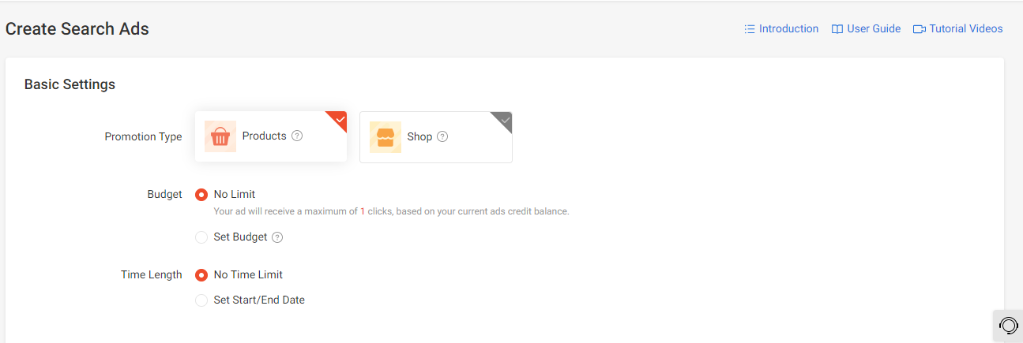
8. 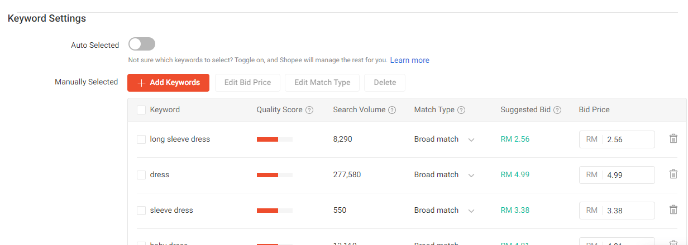

* Add Services/ Edit Services - must have Main Category, sub-category, Each much get data from databases.[Multi-Level Category]

•[System need check, cannot allow vendor key in phone number, email in product description. System auto delete it] - [Done already but need check it]

•Each multi-category is create from admin.

* Modify “Add video” function form previous- last time is use youtube ow need change it



* Vendor can create voucher

1. vendor create voucher need select category and subcategory
2. Time
3. Need pay. For basic - may be can sent 50 users if want sent more so need to pay.
4. Pay is set by admin BUT admin also can set as FREE for this moment. After tried version just start charges

* My Income – will list down all income statement and can download in pdf.
* Also let vendor know total amount will release by this week, month and total
* Example

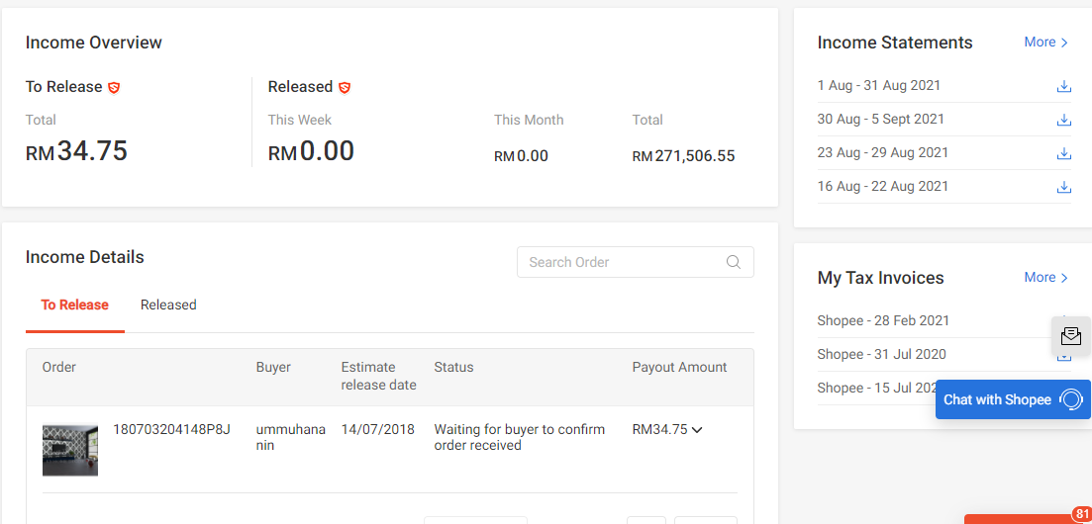

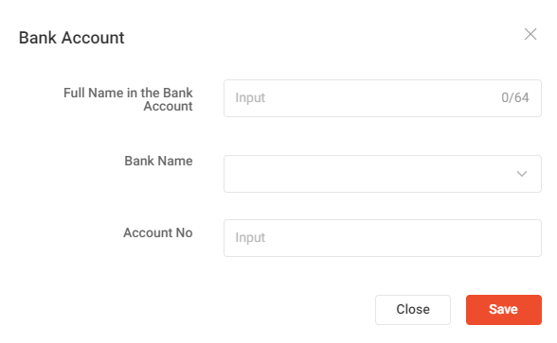

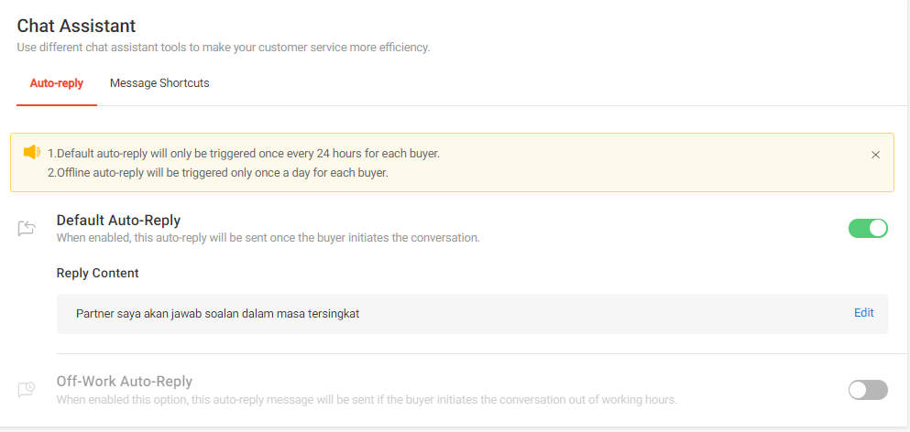

* But have AI test the webpage speed like test if 100 user login into web can do same function, website will “hang” or not
* Admin can create voucher – but voucher have 2-3 type…sometime is FREE % voucher so this voucher ca sent to all customer.
* Second type voucher – Certain customer can get this vouchers may be hit target like 1 month he buy thing more than x.xx money so admin FREE it. So when admin create voucher so admin can set it….
* Admin will **set the product to bid is OK** or not. If ok so can bid, if not ok wil sent back message to seller.
* Admin can SET service as a illegal if think this not suit. So will inform vendor as a service violation. So will disable that service
* **Finance Report – income from ads, income for commission, total sales, amount need to transfer to vendor.**
* Each category super admin will set different commission

• Transfer Function – Need report to transfer money back to each vendor after deduct commission.

i) Every week Admin will make payment to vendor

ii) System need show transfer already and pending transfer. So admin will know

iii) Each must have records. And also allow super-admin upload receipt

iv) In a table must show amount sale, how many commission will deduct, display category for product sale, % will deduct, action button.

* Need to set ADS in system. How many price will charge for new ads for that subcategory by default. May be starting is x.xx amount so after vendor use that ads and set new price so system will update latest price. This table can show to vendor when he want do ads.
* Create FAQ
* Ads Education [video]
* Vendor can chat with admin [function have - Need to check]
* User can make complain to admin if they face problem. [function have - Need to check]
* •Must make sure vendor type description cannot key in phone and email. Need do checking We can use a bot which will filter few names or words, Such as 1- @ 2- gmail or other emails 3- Numbers above 5 letters 4- .com. Need auto delete
* **Must have SEO function [Facebook pixel, meta decription]**
* Need prepare “text area” place to let admin add facebook pixel. So this code will paste into last line <head>fb pixel </head> [[function have - Need to check]

1. Need prepare text area - Meta description also is same. Let admin put the description

Example:<meta name="description" content="This ultimate guide cover all the important aspects of blogging. Find out how to set up a succesful blog or to make yours even better!"/>

* Admin must set package of LIVE, ADS, Report
* Super admin to gove access to admin to view, Edit, Update some function,